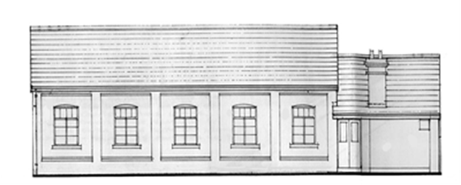

**GRIMLEY PEACE HALL BOOKING FORM AND HIRE AGREEMENT**

**(For private functions e.g. Celebration events, wedding receptions, concerts etc.)**

Grimley Peace Hall Foundation is a Registered Charity, Number 523144.

**THIS AGREEMENT** is made between **Grimley Peace Hall Foundation Committee (The Committee)** and **The Hirer** named below. On payment in full of the hire charge **The Committee** agrees to **The Hirer** using the rooms identified in this form, subject to the Standard Conditions of Hire and the Safety Information of this Hire Agreement as displayed..

**THE HIRER;**

**Email:**

**Address:**

**Postcode:**

**Telephone number:**

**Mobile number:**

**Responsible Person on behalf of The Hirer:**

**On behalf of:**

**ROOMS REQUIRED (please circle the facilities you require):**

All facilities / Main Hall / Committee Room / The Kitchen

**PURPOSE OF THE HIRE**

e.g. Wedding Reception / Dance / Child’s Party / Birthday Party / Public Meeting

Other: (Failure to disclose the true purpose of hire may forfeit the booking and the hire fee)

**Please Note:** Parties for young people will attract a 50% deposit and where judged necessary, an additional charge for the hire of security.

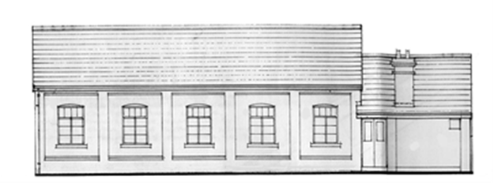

**GRIMLEY PEACE HALL BOOKING FORM AND HIRE AGREEMENT CONTNUED**

**PERIOD OF HIRE REQUIRED (IN LINE WITH T & C)**

Date: Start time: Finish time:

**(Not after Midnight)**

Date: Start time: Finish time:

**(Not after Midnight)**

The keys to the Hall will be available just before the Start Time. The Hall can be set up and cleared away at the same rate.

**ALCOHOL TO BE SERVED:** Yes / No

If alcohol is being sold at an event (this also includes a free glass of alcohol as part of a ticket), a Temporary Events Notice (TEN) must be applied for from Malvern Hills District Council (MHDC) at a cost detailed by the Council. The licence application must be received by MHDC Licensing department, and a copy sent to the Committee.

If the event is a private party, alcohol is permissible without a TEN if no tickets are sold, and the alcohol is given free.

**BOOKING DEPOSIT**

A non-refundable booking deposit is payable, and the amount will be determined as follows:

**A 25% deposit will be required (except in the circumstances detailed on page 3) within 24 hours of receipt of an invoice . This will need to be evidenced in order to secure the booking.**

The deposit will normally be deducted from the final invoice provided there has been no damage or contravention of the hire conditions.

**HIRE CHARGE**

Please refer to the current pricing list

Additional heaters must not be used unless permission is given and they are PAT tested and the charges are agreed. The rule concerning heaters applies to any additional equipment used in the premises.

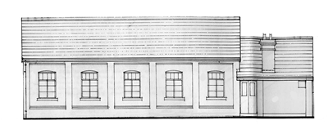

**GRIMLEY PEACE HALL BOOKING FORM AND HIRE AGREEMENT CONTNUED**

The Hire Charge is to be paid upon presentation of an invoice. The deposit is to be paid 14 days prior to the date of hire.

**HALL CAPACITY**

Maximum licensed capacity is 150 people.

The recommended maximum for the Main Hall is 140, the Committee Room 10. However, depending upon the situation these numbers may have to be reduced in the interests of Health and Safety.

**CORONAVIRUS**

All necessary precautions should be followed with reference to the Pandemic. The Committee reserves the right to terminate a hire agreement if current Government guidelines are not followed in respect to the Coronavirus.

**SIGNATURES**

As **The Hirer, I have read and agree to the** Standard Conditions of Hire and Safety Information. I hereby accept responsibility for being in charge of the premises for the period of my hire and for ensuring that all conditions of the Premises Licence relating to management and supervision of the premises are met.

**I am over 18 years of age.**

**On behalf of The Hirer:**

**Date:**

**On behalf of The Committee:**

**Date:**

Please **sign and return** this form with your deposit for your booking to be confirmed.

**Return to:** grimleypeacehall1967@gmail.com

**Key Holders:** Sam Siverns-Davis **(**Booking Secretary): 07909 090924

Wendy Tinley (Treasurer) 07919 913013 or 01905 641572

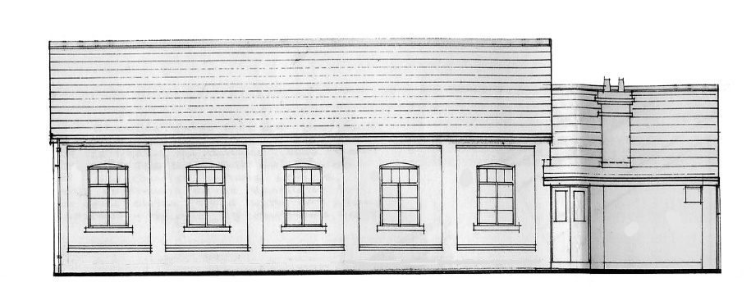

## ***GRIMLEY PEACE HALL***

**FOUNDATION**

SINTON GREEN

WORCESTERSHIRE

WR2 6NP

# WORCESTER

WR2 6NP

Serving Grimley, Sinton Green and Monkwood Green

**TERMS AND CONDITIONS CONCERNING THE HIRE OF GRIMLEY PEACE HALL**

**PLEASE NOTE ACCEPTANCE BY THE GRIMLEY PEACE HALL FOUNDATION OF ANY BOOKING IMPLIES THAT THE HIRER HAS AGREED TO THESE CONDITIONS.**

The accommodation available at Grimley Peace Hall comprises:

Capacity

Main Hall 140

Committee meeting room 10

Kitchen

1. The Hirer must be 18 years of age or over and for the purposes of these conditions shall be the “responsible person.”
2. The hirer will be responsible for:
3. Ensuring the conditions of hire are observed by those attending the function. Prior to any booking the hirer will be required to sign a form indicating acceptance and understanding of the conditions.
4. Only using the premises for the purpose as described in the hiring agreement and shall not sub-hire or use the premises or allow the premises to be used for any unlawful purpose or in any unlawful way do anything or bring onto the premises anything which may endanger the same or render invalid any insurance policies in respect thereof.
5. The cost of making good damage caused to the premises, furniture, fittings etc. or loss of items to the premises. Any damage or loss shall be reported to the Booking Secretary.
6. Arranging and putting away of tables and chairs, the removal of all rubbish, and leaving the Hall, including toilets, kitchen, and any other rooms, in a clean and tidy state, properly locked and secured unless directed otherwise. Failure to do so may

incur an additional charge and/or loss of the Special Deposit at the discretion of the Grimley Peace Hall Foundation.

1. Ensuring all persons on the premises act in a seemly and orderly manner.
2. Ensuring that the occupancy of the premises specified are not exceeded.
3. Ensuring that a named person is made responsible for familiarising themselves with the fire safety and evacuation procedures and making them clear to all people using the Hall and that those procedures are adhered to.
4. Ensuring that all exits are kept clear.
5. Ensuring that those attending the function are made aware of the exits which should be used in the event of an emergency.
6. Ensuring that the exit signs are always illuminated during the use of the Hall.
7. Ensuring that no unauthorised persons are allowed access to the premises.
8. Ensuring that no alcohol is consumed by persons under 18 years of age.
9. Ensuring that no illegal substances are brought onto or consumed on the premises.
10. Ensuring that nothing is done on or in relation to the premises in contravention of the law relating to gaming, betting, and lotteries.
11. Ensuring that any electrical appliances brought by the Hirer and / or entertainer to the premises (with the approval of the Grimley Peace Hall Foundation) and used there are in good working order and used in a safe manner.
12. Ensuring that no unauthorised heating appliances are used on the premises without the consent of the Grimley Peace Hall Foundation. Portable Liquefied Gas (LPG) should not be used.
13. Ensuring that no Sellotape, blutak or drawing pins are used on the walls. No posters or decorations must be stuck to the walls – there are hooks available to hang decorations and a notice board for displaying posters.
14. Ensuring that if an official bar is in place, no unauthorised alcohol shall be brought onto the premises.
15. Ensuring that, under no circumstances, should the vehicular entrance to the Hall premises be blocked in such a way to prevent access or egress to the premises.
16. Ensuring that no dogs (except guide dogs) or animals including birds are brought into the Hall and no animals to enter the kitchen at any time.
17. Observing all relevant food health and hygiene legislation and regulations if preparing, serving, or selling food on the premises.
18. Obtaining such licences as may be needed whether for sale or supply of intoxicating liquor. Sight of such licences must be provided to the relevant member of the Grimley Peace Hall Foundation or Bookings Secretary before the day of hiring.
19. Ensuring that any activities for children under the age of 8 years old comply with the provisions of The Children’s Act 1989 and that only fit and proper persons have access to the children.
20. Ensuring that smoking is not allowed within the Grimley Peace Hall premises.
21. Ensuring excessive waste is removed from the Hall together with any recyclables. Some rubbish may be left in black disposable bags.
22. Failure to make full payment for hiring the Hall may result in refusal for future bookings. Payment must be made by BACS or cheque, **no cash will be accepted**.
23. The Grimley Peace Hall may be hired during the following hours:
24. Monday to Saturday – 09.00 to 24.00. Any bar or disco shall end at 23.30. Premises to be empty by 24.00.
25. Sunday – 09.00 to 23.00. Any bar and disco shall end at 22.30. Premises to be empty by 23.00.

Any variation to the above times will require the express permission of the Grimley Peace Hall Foundation with at least 28 days’ notice. All relevant licences must also be produced for the Foundation’s perusal.

1. Failure to vacate the premises on time may, at the discussion of the Grimley Peace Hall Foundation, result in additional charge.
2. Failure to clear the premises of any equipment at the conclusion of a letting may incur an additional charge at the discretion of the Grimley Peace Hall Foundation.
3. If the hirer wishes to cancel the booking before the date of the event and the Grimley Peace Hall Foundation is unable to find a replacement booking, the question of the payment or repayment of the fee shall be at the discretion of the Grimley Peace Hall Foundation.
4. The Grimley Peace Hall Foundation does not accept liability for loss or damage to articles or clothing left on the premises.
5. The Grimley Peace Hall Foundation does not accept liability for loss or damage to cars or vehicles parked on the premises of the Hall.
6. The Grimley Peace Hall Foundation reserves the right to charge a Special Deposit at the discretion of the Booking Secretary. The Special Deposit will be refunded within 28 days of the termination of the period **provided that** no damage or loss has been caused to the premises and / or contents during the period of hire as a result of the hiring and no extra cleaning costs have been incurred.
7. The Grimley Peace Hall Foundation reserves the right to vary the hire charges and the conditions of hire at any time and without notice.
8. Hirers are asked to please respect our local residents by ensuring that those attending a function keep noise levels to a minimum on arrival and departure.
9. The Grimley Peace Hall Foundation reserves the right to cancel the hiring in the event of the Hall being required for use as a Polling Station for a Parliamentary, European or Local Government election or bye-election, in which case the Hirer shall be entitled to a refund of any deposit already paid.
10. The Bookings Secretary reserves the right to refuse a booking without notice or to cancel the hiring agreement at any time either before or during the term of the agreement upon giving 7 days’ notice in writing to the Hirer.

The Hirer shall be entitled upon such notice to reimbursement of such monies including the deposit as have been paid by the Hirer to the Grimley Peace Hall Foundation. The Grimley Peace Hall Foundation shall not be liable to make any further payment to the Hirer.

1. The Grimley Peace Hall Foundation reserves the right to cancel the hiring if all necessary precautions have not been followed with reference to the Pandemic. The Committee reserves the right to terminate the hire agreement if current Government guidelines are not followed in respect to the Coronavirus whilst using the premises.

**INFORMATION.**

Any complaint relating to the hire of the Grimley Peace Hall should be made initially to the Bookings Secretary or any member of the Grimley Peace Hall Foundation.

If the matter is not resolved, complaints should be made in writing to the Grimley Peace Hall Foundation.

**Booking Secretary Sam Siverns-Davis**

**Grimley Peace Hall Foundation Wendy Tinley**

**Annette Davies**

**Margaret Leary**

**Carol Allen**

**William Allen**